Annual General Meeting of North West Region Analytical Division
The North West Region Analytical Division (NWR-AD) enjoyed the kind hospitality of the Catalyst Science Discovery Centre, Widnes who hosted this year’s AGM on the evening of 29th April 2010. Members were welcomed by Sue Halliday, Education Manager, and other staff at the Centre for an interesting programme of presentations and demonstrations which focussed on teaching science to primary and secondary school children.
Sue introduced the evening with an overview of the many educational activities now provided in the Centre’s splendid facilities which members could witness at first hand. Lorelly Wilson then entertained us with her “Chemistry with Cabbage” presentation which she has developed to stimulate youngsters interest in chemical science by providing a range of safe and inexpensive hands-on experiments carried out using commonplace household materials. The “hands-on” theme, which is seen as essential to developing children’s interest in science, continued when members were given the opportunity to use the laboratory facilities and, under instruction from some of the Centre’s enthusiastic education team, make blocks of soap from base ingredients or moulded models using thermo-softening polymers. Sue then gave us a demonstration of the lecture theatre’s interactive capabilities by illustrating some chemical manufacturing processes and asking members to answer a series of questions using their hand-held consoles.

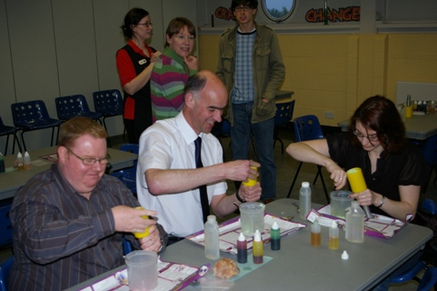
I wouldn’t buy any of this soap !
Following a splendid buffet provided by staff at the Centre, the evening concluded with the formal NWR-AD AGM during which Elsa Faria-Billinton was confirmed as the Chairman for 2010-2012 in succession to Megan McLean and Steven Black was elected as Vice-Chairman; Stuart Forbes and Peter Doyle were re-appointed as Honorary Secretary and Honorary Treasurer respectively.

