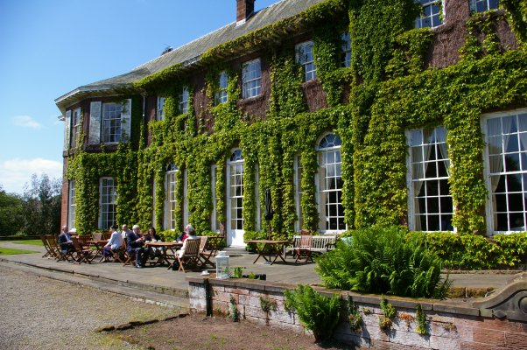

Analytical Division NW Region Long Service Lunch and talk by Dr Ian Cubbin

17th June 2010
Burton Manor, The Village , Burton, Neston Cheshire, CH64 5SJ. Tel 0151 336 5172
Timings:
12:00 for start at 12:30 hrs - Long Service Lunch

14:00 “Victorian Pharmacy - The Science behind the Medicine”
“The Royal Pharmaceutical Society was founded in 1841 and this lead to the regulation of Medicines .The first British Pharmacopoeias was produced in 1864 which laid down the standards for drugs for Human Consumption. The talk will consider some of the interesting (poisons) remedies and their long genity”.
Royal Society of Chemistry Luncheon 17th June 2010

Name (s) ……………………………………………….

To start
Tomato and Basil Soup | * | *
OR
Pate Salad | * | *
OR
Fruit Juice | * | *

Lunch Main Course
Traditional Roast Beef | * | *
OR
Baked Cod with a Mornay Sauce | * | *
OR
Greek Cheese Slice | * | *
All Served with Roast Potatoes and a Selection of Vegetables

Dessert
Steamed Syrup Sponge and Custard Sauce | * | *
OR
Raspberry and Chocolate Tear with Fruit Coulis and fresh Raspberries | * | *
OR
Ice Cream | * | *
OR
Cheese and Biscuits | * | *
Tea and Coffee

*Please indicate your choices for yourself and partner (if applicable) by Wednesday the 19th May and send this page to:

A J Handley, LGC Ltd, The Heath, Runcorn, Cheshire, WA7 4QX
Or e-mail to alan.handley@lgc.co.uk
COPY for Retention

Royal Society of Chemistry Luncheon 17th June 2010

To start
Tomato and Basil Soup | * | *
OR
Pate Salad | * | *
OR
Fruit Juice | * | *

Lunch Main Course
Traditional Roast Beef | * | *
OR
Baked Cod with a Mornay Sauce | * | *
OR
Greek Cheese Slice | * | *
All Served with Roast Potatoes and a Selection of Vegetables

Dessert
Steamed Syrup Sponge and Custard Sauce | * | *
OR
Raspberry and Chocolate Tear with Fruit Coulis and fresh Raspberries | * | *
OR
Ice Cream | * | *
OR
Cheese and Biscuits | * | *
Tea and Coffee

*Please indicate your choices for yourself and partner (if applicable) by Wednesday the 19th May and send this page to:
A J Handley, LGC Ltd, The Heath, Runcorn, Cheshire, WA7 4QX
Or e-mail to alan.handley@lgc.co.uk

Directions
Burton Manor is situated on the Wirral, just off the A540, 3 miles from Neston, 4 miles from Hooton and 9 miles from Chester Rail Stations. From the East, we are about 1 mile before Ness Gardens.
From the A540, follow the rural signs for Ness Gardens until the centre of Burton village. We’re on the left!

By Car
Follow the rural signs for Ness Gardens but stop in Burton!

From Liverpool - 14 miles
- Use the Wallasey Tunnel
- Follow the M53 to Junction 5
- Right onto A41 (Chester)
- At 2nd set of lights (right after the 1st set) turn right onto A550 (North Wales)
- At major traffic lights (Mini and Two Mills Honda Showrooms opposite) turn right onto A540 (Hoylake).
- # At 3rd road on the left (3rd set of lights), turn left into Dunstan Lane (signposted Burton/ Ness Gardens) and proceed 0.9 miles up a gentle hill, then over the crest (into a regulated speed zone) down the hill into Burton itself).
(N.B. It IS possible to take the 2nd (narrower & twisty) road on the left, Mudhouse Lane (1st set of lights, signposted Burton Manor College) and to turn left at the end into Dunstan Lane).
- + Burton Manor is in Burton village on the left about 300 metres down the gentle hill (look for a red phonebox before the long, tall sandstone wall and find an entrance half way along)
From Chester - 8 miles
- From Fountains Roundabout follow A540 Parkgate Road (Birkenhead & Ellesmere Port)
- Stay on A540, follow signs for Hoylake
- Straight on at roundabout (Mercedes Garage on right)
- Straight on at major junction with A5117 (Petrol Station on right)
- At major traffic lights (Mini and Two Mills Honda Showrooms on left) continue straight on A540 (Hoylake).
- Then as from #, above
From West Kirby - 8 miles
- Follow A540 (Chester). Burton Manor College is signposted from the A540 Parkgate Road.
- Continue through Heswall, past Parkgate and Neston turnoffs to major lights (staggered junction with first road on right - second road on left goes to Willaston), turn right into Dunstan Lane.
- Then as from +, above.
From Manchester - 40 miles
- Take M56 West right to the motorway end
- At the end of M56 come off left on the ramp (A540 Hoylake), take the right lane (the other is signed Chester) and, at the roundabout, turn right onto the A540 (direction Hoylake). N.B. This junction was modified in 2009.
- At major traffic lights (Mini showroom and Two Mills Honda Showroom on left) continue straight on A540 (Hoylake).
- Then as from #, above.

